Creating Bridge on JMSType

First we need to create topiccs and queues and create bridge as below

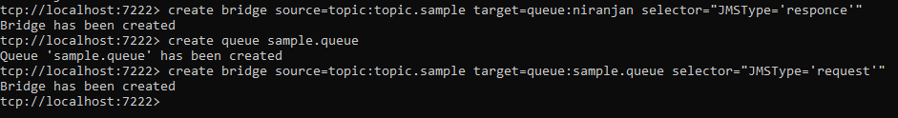

And configure selector on Studio As below.

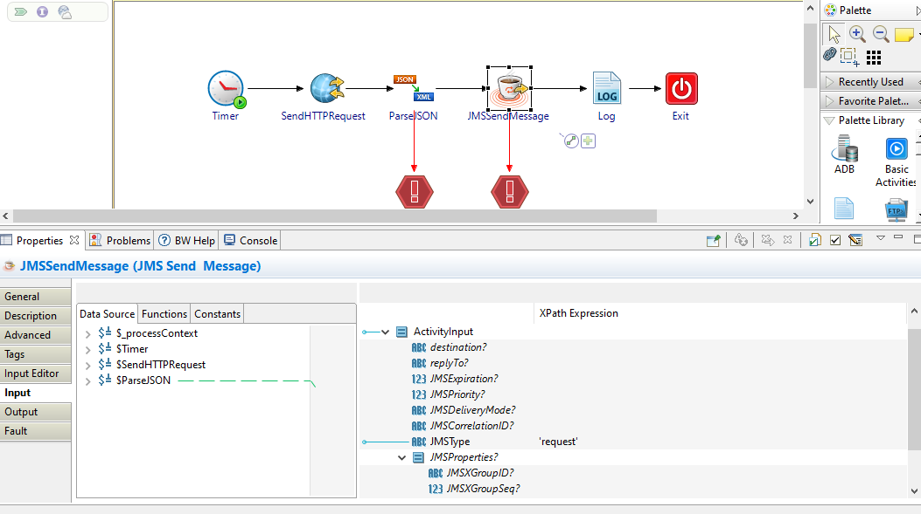

And output will be as below

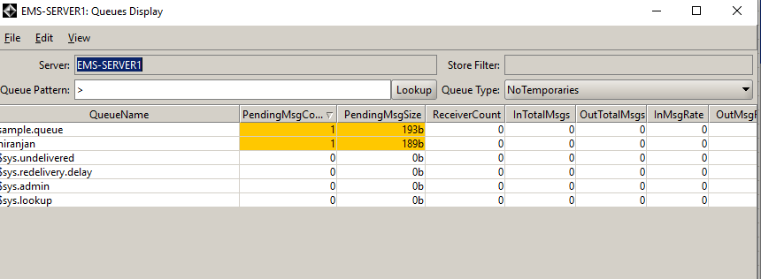

If Redelivery Delay propertyis enable and we need to mention the redelivery delay time on gems.

The Redelivery Delay Time should be Between 15sec to 28800 sec.